Year 10
Pathway 1

Surface Area and Volume Topic Test

Name: ______________________ Time: 25 minutes Total Mark:____/29

Show working and answers on this sheet. Show working in sufficient detail to support your answers. Incorrect answers without supporting reasoning will be allocated zero marks.

Resources: 1 A4 page of notes (1 side), Calculator allowed.

Question 1 1 mark

A cube has a total surface area of 384 cm2. The length of the edge of the cube is

- 9 cm
- 8 cm
- 7 cm
- 6cm
- 3cm


Question 2 1 mark

Find the volume of a sphere is 14137.17cm3. What is the radius

- 1.2 cm
- 150 mm
- 7 cm
- 50 mm

Question 3 12 marks

Find the volume and the surface area of the following shapes

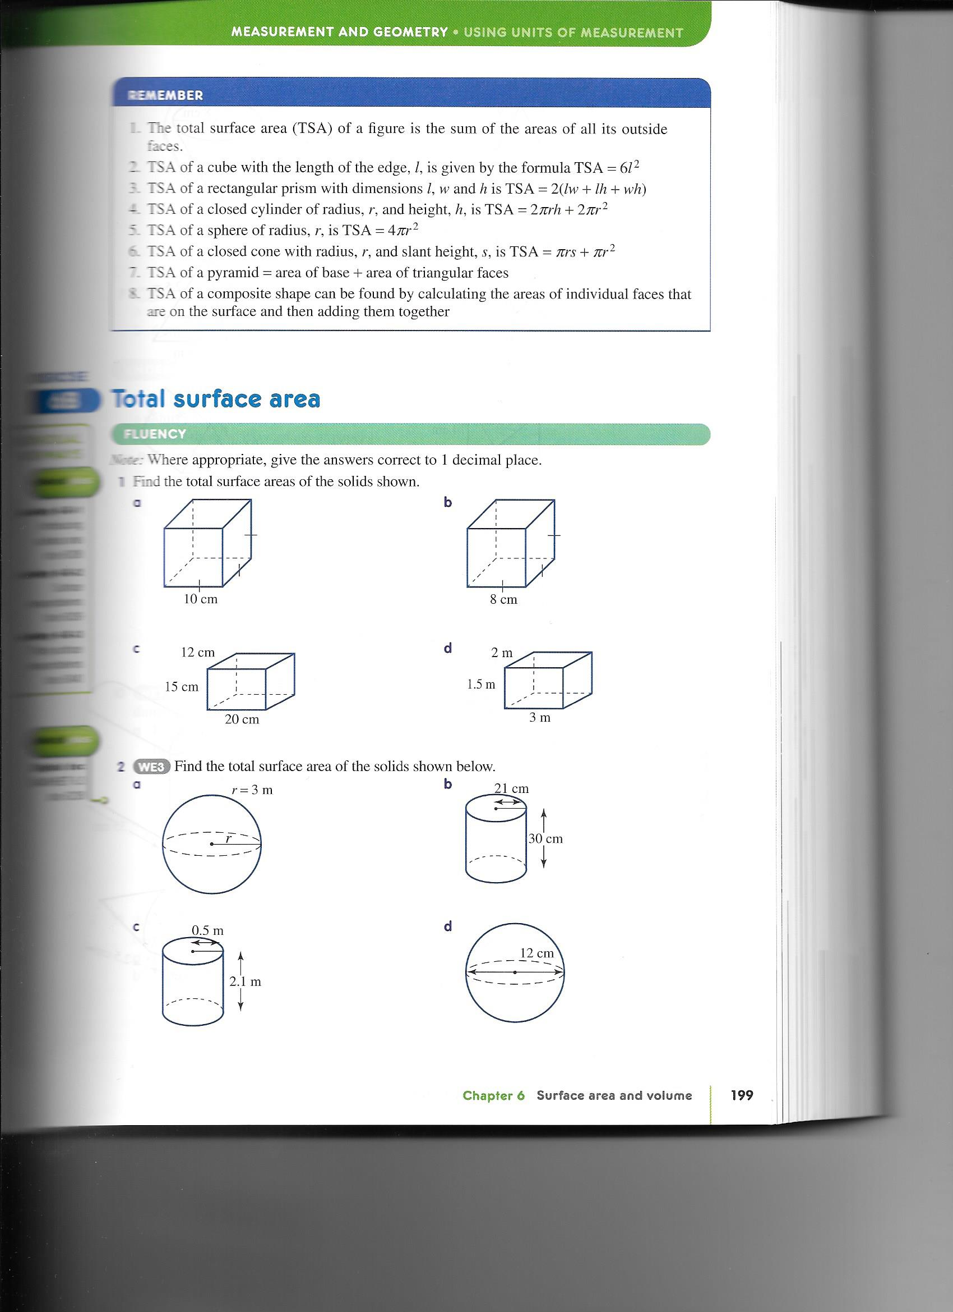

- 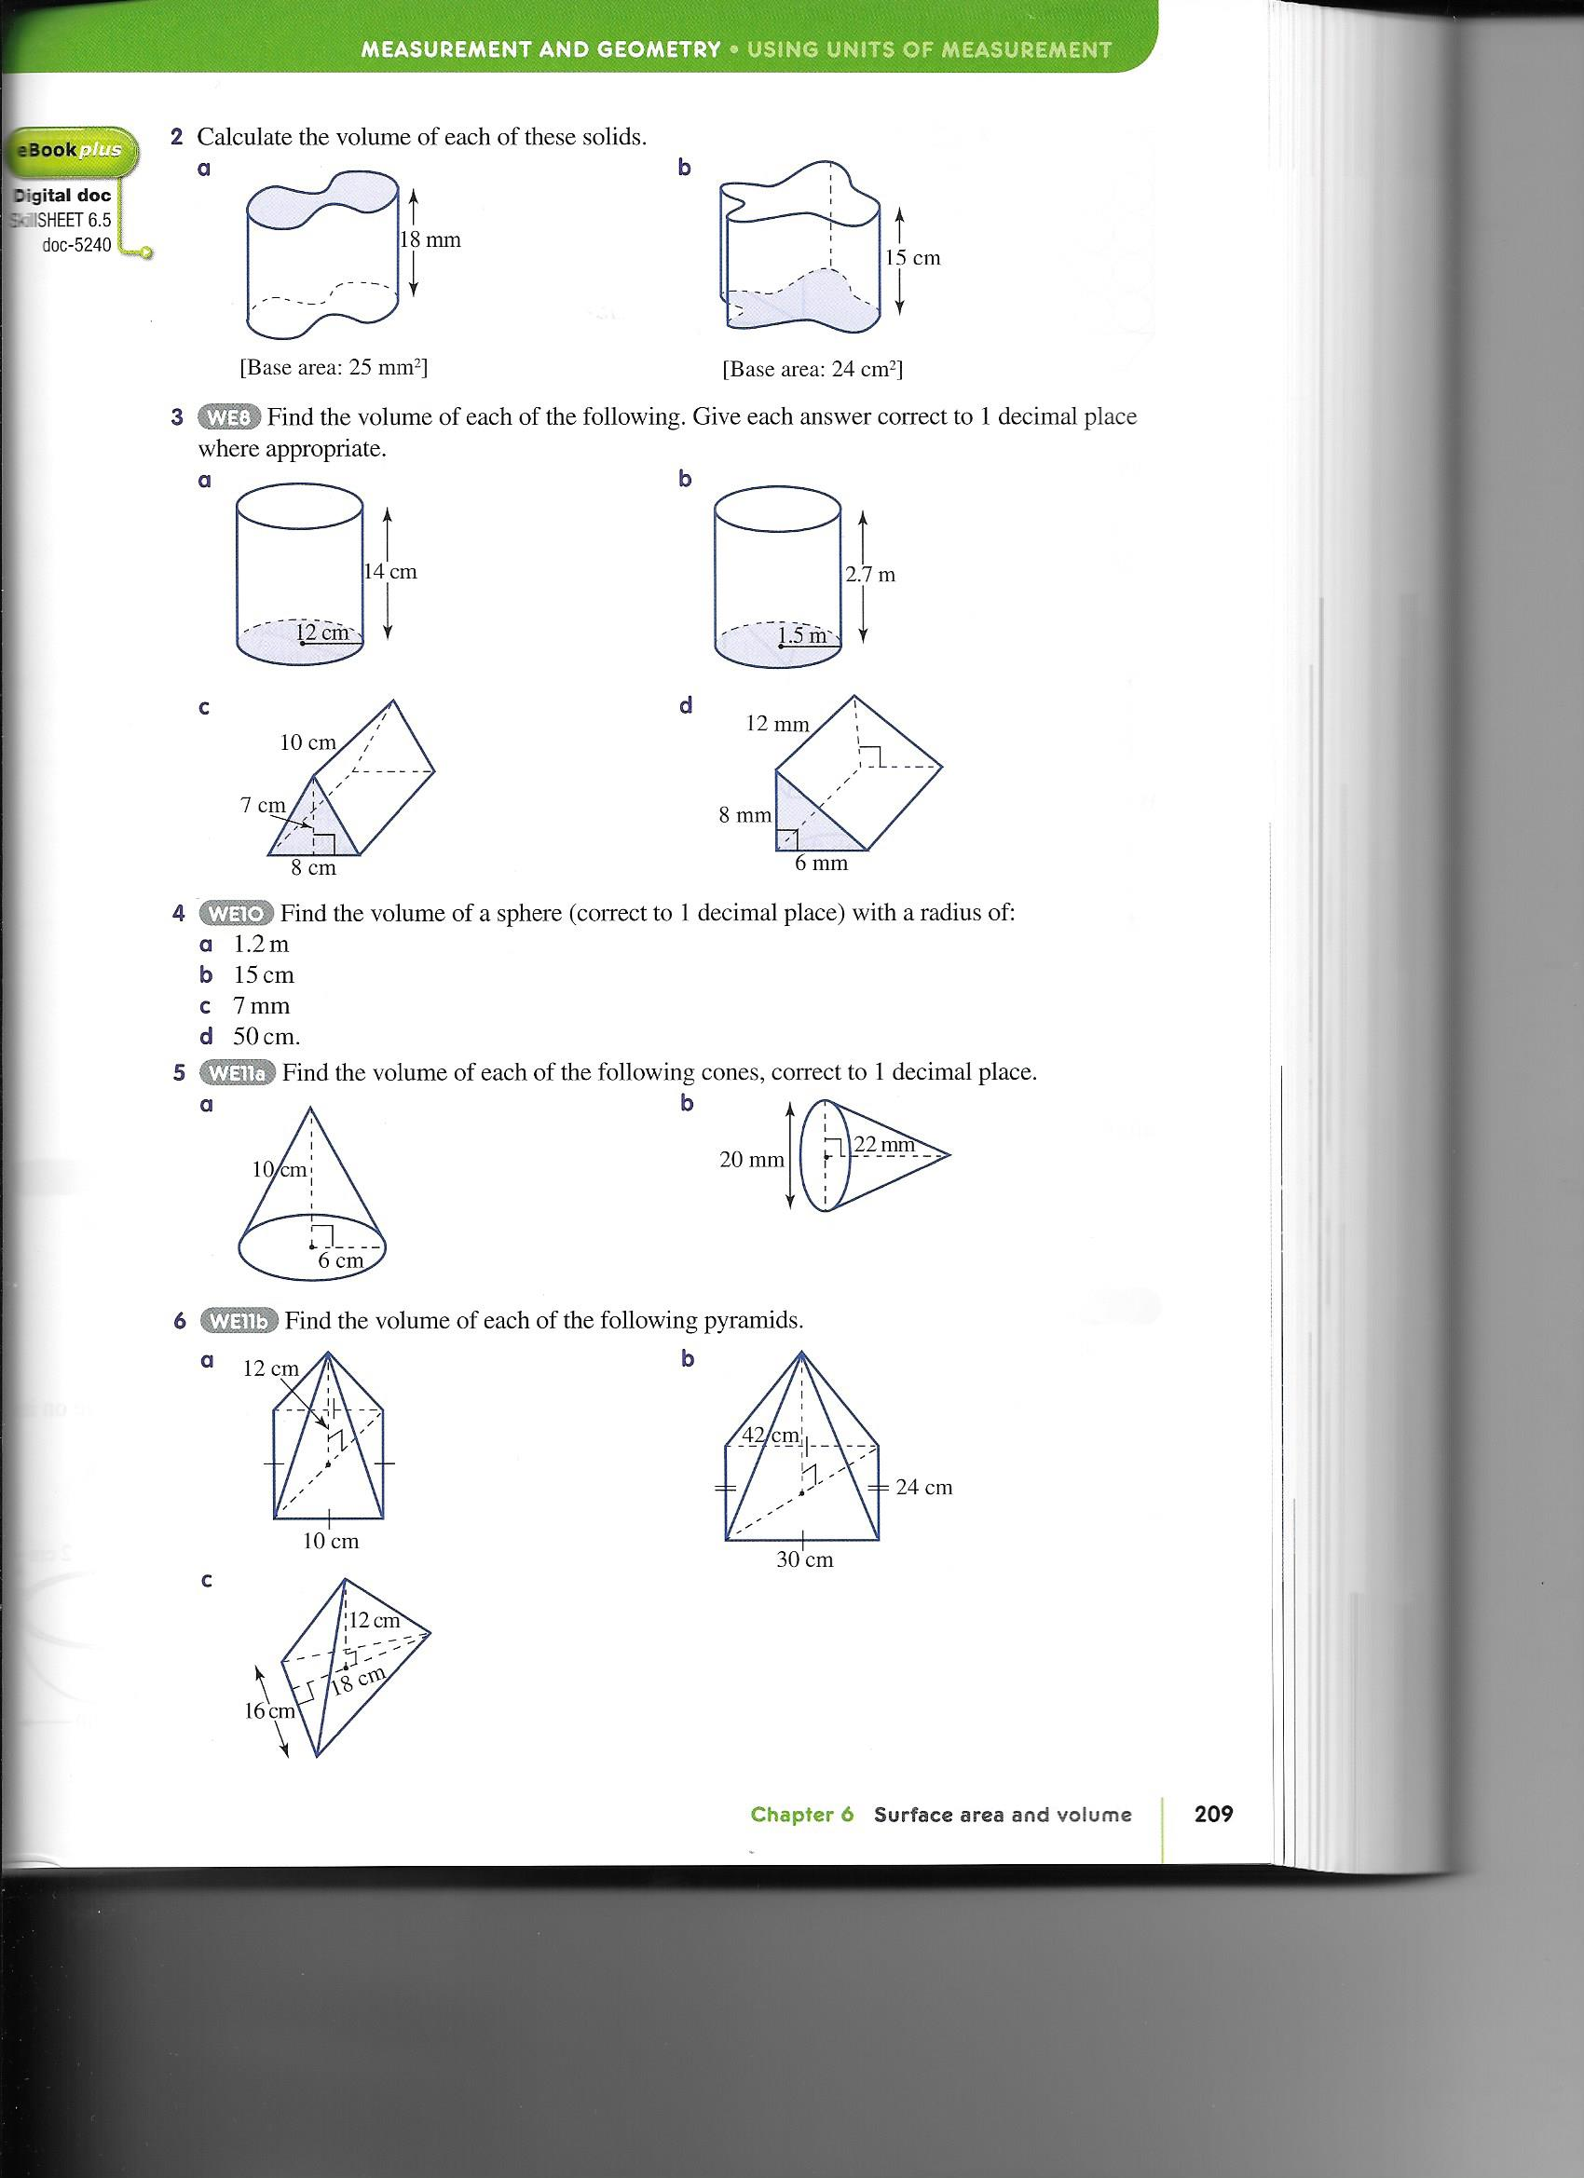
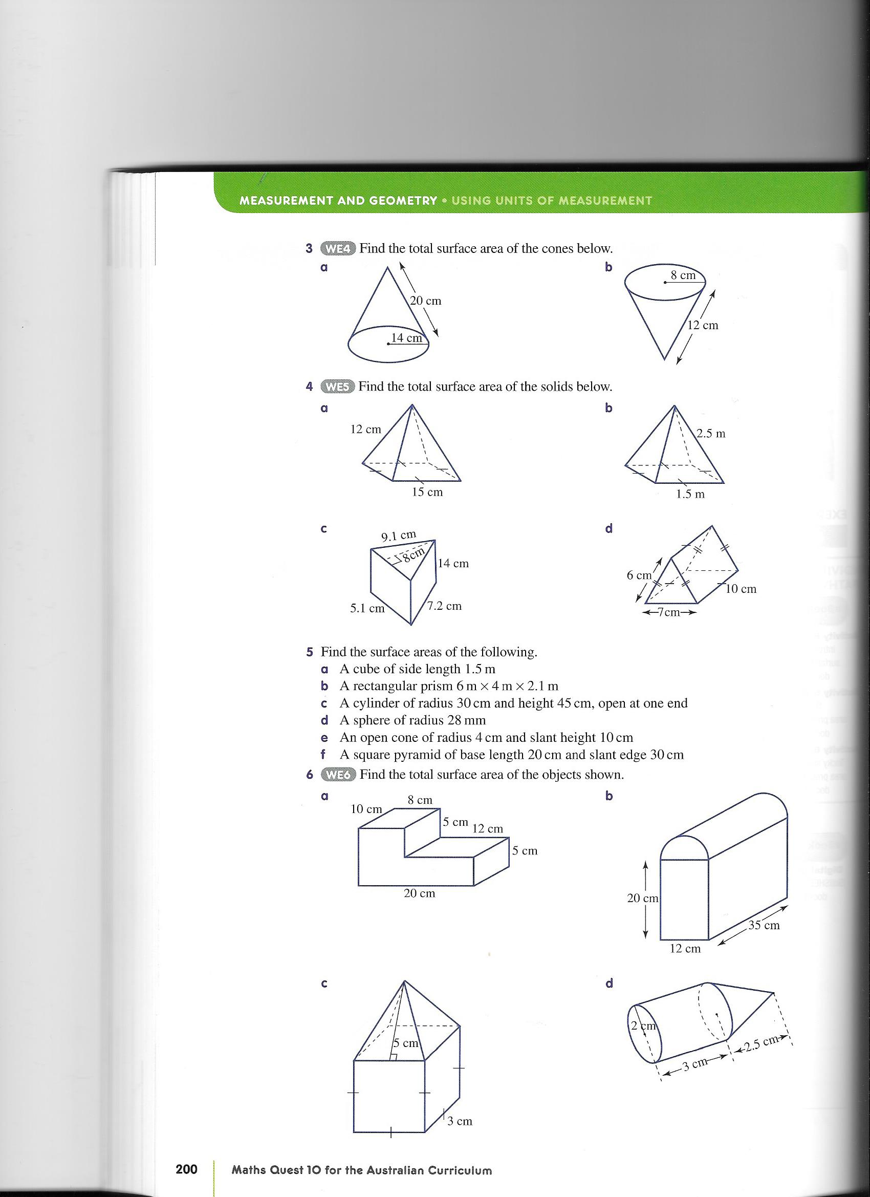

Question 4 15 marks

Western Wheat has two rows of silos for storing wheat. Each row has 8 silos. The first row of silos have a cylindrical base (height 6m; diameter 4m) with a conical top (diameter 4m; height 2m; slant height 2.83m). The second row of silos have a cylindrical base (height 6m; diameter 4m) with a dome top (diameter 4m).

- What is the surface area of all the silos.
- How much wheat can be stored altogether in these silos
- The wheat is emptied into trucks with rectangular containers 2.4m wide,5m long and 2.5m high. How many truckloads are needed to empty all of the silos.

END OF TEST

